Dear Parents,

Change of Collection Arrangements at the End of School Day

Information was collected on the school admission form about who collects your child. If there are any changes to the information which we hold, please could you complete the section below for each child in the school and return the tear-off section.

Thank you,

Mr Raphael Moss
Headteacher

Child’s Name

Class

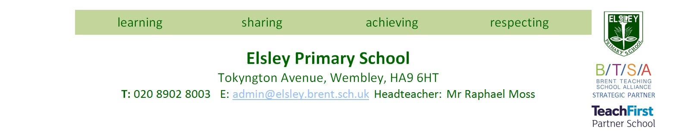


Collected by

CHILDMINDER

Name/Contact Number

Collected by
RELATIVE/FRIEND OF PARENT

Name/Contact Number


Collected by
PARENT OF ANOTHER CHILD WITHIN THE SCHOOL

Name/Contact
Number

(
include name of child and class
)


(Please note arrangements must be made in advance before informing the school)

My child is allowed to walk home alone

Years 3 to 6 only

Parent’s Signature Date

